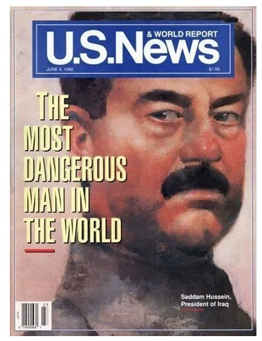

(21)

The fall of the Soviet Union lead to the fall of the Berlin Wall in November 1989 and the end of the Cold War. Shortly after that the media seemed to be clamoring for another enemy. It is a fundamental Machiavellian principle that maintaining power and control over the masses requires the fear of a strong enemy. If one does not exist, one must be created. "A sharply defined enemy is a far stronger argument for your side than all the words you could possibly put together." (1)
Iraq declared war on on Iran on September 22, 1980. The US and its allies provided billions of dollars to Iraq in support of punishing Iran for having the audacity, in 1979, to throw out the dictator that the US installed in 1941. The Shah of Iran maintained a pro-Western foreign policy for 38 years. After the Iran-Iraq war ended on August 20, 1988, and after the fall of the Soviet Union in 1989, Saddam Hussein became the ideal target. The media had headline after headline like: “A million man army,” “chemical and nuclear weapons” (2) “A Loose Cannon” “Weapons of Mass Destruction.” (3) Another principal of power is “Repeat a lie often enough and it becomes the truth” (11)
Saddam Hussein was easily manipulated into invading Kuwait. The US provided technology for Kuwait to slant drill into Iraq and steal their oil.(4) US Ambassador April Glaspie assured Saddam Hussein that "We have no opinion on your Arab-Arab conflicts" and that "the Kuwait issue is not associated with America." These were interpreted by Saddam Hussein as giving free rein to handle his disputes with Kuwait as he saw fit.(5) Saddam Hussein invaded Kuwait on August 2, 1990.
This was followed by stories that Iraqi soldiers had removed scores of babies from incubators and left them to die and that Saddam Hussein fed their adversaries into a plastic shredder or wood chipper, both would later be proven false. (17)
6 months later “the Liberation of Kuwait was a U.S.-led military operation to retake Kuwait from Iraq after a massive air campaign between 24–28 February 1991. U.S. troops and the Coalition entered to find the Iraqis surrendering en mass.” (12)
Then a United States-led coalition invaded Iraq on Mar 20, 2003 and the war ended on Dec 15, 2011. This“Second Invasion of Iraq in 2003 dubbed “Operation Iraqi Freedom,” in a US-UK led coalition to topple Saddam Hussein and his Ba’athist government. By the time of the invasion, Iraq had been crippled by more than ten years of economic and military sanctions.” A U.N. Report estimated 576,000 Iraqi children died of malnutrition due to the economic sanctions with enthusiastic British and American governmental support along with destroying their water supply and daily relentless bombing that murdered Iraqi civilians and subjected its survivors to uranium-related cancers for which the Sanctions Committee in New York had blocked or delayed vital medical equipment including chemotherapy drugs and pain-killers. This left suffering cancer patients in Iraq including children to die. (20)
The US stated that the intent was to remove "a regime that developed and used weapons of mass destruction, that harbored and supported terrorists, committed outrageous human rights abuses, and defied the just demands of the United Nations and the world.” (9) “In 2004, the 9/11 Commission said there was no evidence of an operational relationship between the Saddam Hussein regime and al-Qaeda. No stockpiles of WMDs or an active WMD program were ever found in Iraq.” (10)
After 10 years of totally baseless and unnecessary wars on Iraq, the United States coalition casualties were 4,825 and Iraqi coalition casualties were 31,608. (10)

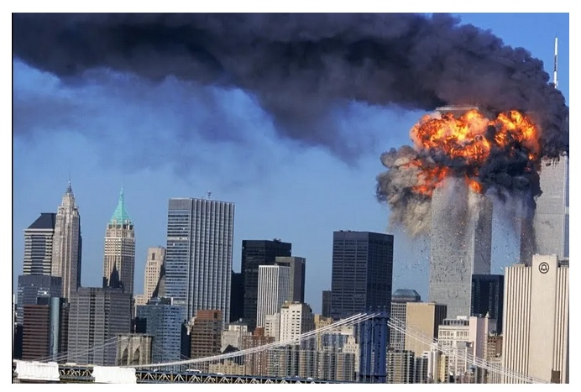

(22)

In his 1998 fatwa, Osama Bin Laden declared war against the United States. One of his main grievances was “their eagerness to destroy Iraq, the strongest neighboring Arab state."(6) This was not only an act of terror it was an act of revenge.

Then, after he produced the 911 attack on the World Trade Center, we had a new enemy to fear. The War on Islam was expanded throughout the Middle East.
Few know that revenge is an old Arab custom that has unfortunately become a part of the Muslim tradition worldwide. It is claimed that the horrific recent bombings in Paris had been in revenge for the role of France in bombing ISIS fighters in Syria. (18) Add to that, the fact that they are not afraid to die, the result is an enemy that generates an extremely high level of fear. (19) And control is all about fear.
There have been numerous wars in the middle east with Afghanistan being the most costly. From 2001 to 2019 there were 4030 coalition forces killed and “According to the data provided by the US Central Command Combined Air Operations Center, the US air force dropped a record 7,423 bombs on Afghanistan – more than at any time in the last 10 years. More than 100,000 Afghans have been killed or wounded since 2009 when the UN Assistance Mission in Afghanistan began documenting casualties.”
“Since 2001, Washington has spent more on nation-building in Afghanistan than in any country ever, allocating $133 billion for reconstruction, aid programs and the Afghan security forces.” (13)
“Inspector General Stuart W. Bowen released in March of 2013 the final report on the U.S. reconstruction effort in Iraq. The report contends that over nine years (2003-12) the U.S. spent more than $60 billion trying to rebuild the country, with some $9 billion wasted due to incompetence and fraud.” (14) And you better believe that there were plenty of well connected rich people that took their cut. Follow the money.

COSTS OF ENDLESS WAR, HUMAN COST, COST TO VETERANS

(23)
The United States has been involved in wars and military actions in over 30 countries since WW2, (16) The establishment (especially the military industrial establishment) does not like the Trump peace agreements at all. There is profit in war. “What he has done with the Trump Doctrine is that he has decided he would no longer have America in endless wars, wars which achieve nothing but the killing of thousands of young Americans” and over one hundred thousand Muslim casualties with the War on terror.(7). “So, he's reducing America's tendency to get involved in any and every war,” (8)
Lets pray that this trend continues.

References:
1) https://medium.com/@skueong/the-48-laws-of-power-214b92dc55a6 https://anotheropinionatedyouth.wordpress.com/2007/09/07/how-to-create-an-enemy-in-10-easy-steps/
2) https://www.latimes.com/archives/la-xpm-1990-08-13-mn-465-story.html
3) https://en.wikipedia.org/wiki/Iraq_and_weapons_of_mass_destruction
https://www.ducksters.com/history/us_1900s/iraq_war.php
4) https://www.timesheraldonline.com/2010/05/28/slant-drilling-ignored/
5) https://en.wikipedia.org/wiki/April_Glaspie
6) https://en.wikipedia.org/wiki/Beliefs_and_ideology_of_Osama_bin_Laden#United_States_of_America
7) https://en.wikipedia.org/wiki/War_on_terror
8) https://thehill.com/homenews/administration/518842-trump-nominated-a-third-time-for-nobel-peace-prize
9) https://en.wikipedia.org/wiki/Rationale_for_the_Iraq_War
10) https://en.wikipedia.org/wiki/Iraq_War
11) https://www.bbc.com/future/article/20161026-how-liars-create-the-illusion-of-truth
12) https://en.wikipedia.org/wiki/Liberation_of_Kuwait_campaign
13) https://www.washingtonpost.com/graphics/2019/investigations/afghanistan-papers/afghanistan-war-nation-building/
14) https://www.ipi.org/ipi_issues/detail/calculating-the-incalculable-cost-of-iraqi-nation-building
15) https://www.aljazeera.com/news/2020/9/12/from-the-2001-fall-of-the-taliban-to-2020-afghan-peace-talks
16) https://en.wikipedia.org/wiki/List_of_wars_involving_the_United_States
17) https://citizentruth.org/fake-news-1990-that-ignited-gulf-war-sympathy/
18) https://www.outlookindia.com/website/story/understanding-the-role-of-revenge-in-islam/295883
19) https://www.nairaland.com/2314493/why-muslims-not-afraid-death
20) https://theduran.com/historys-deceptive-buildup-against-saddam-hussein/
http://aldeilis.net/terror/1873.pdf U.N. Report, Iraq Sanctions Kill Children
https://gh.bmj.com/content/6/2/e004166 Depleted Uranium Weapons used in Iraq
21) https://www.usnews.com/news/national/articles/2008/05/16/a-prescient-warning-about-saddam-hussein
22) https://i.ytimg.com/vi/R4ZHOHrOWuk/maxresdefault.jpg
23) https://i2.wp.com/winwithoutwar.org/wp-content/uploads/2016/10/Afghan-15-full-info.png

